**Advance Database Management System Lab**

**Experiment- 11**

**To understand the concepts of implicit and explicit cursor.**

**Aryan Mohan**

**500092142**

**Batch- 2**

--1. Using implicit cursor update the salary by an increase of 10% for all the records in EMPLOYEES table, and finally display how many records have been updated. If no records exist display the message “No Change”.

Create database LabExperiment11;

USE LabExperiment11;

CREATE TABLE EMPLOYEE( EMPID INTEGER PRIMARY KEY, ENAME VARCHAR(30), JOB VARCHAR(20), MGR INTEGER, HIREDATE DATE, SALARY INTEGER, COMM INTEGER, DEPTNO INTEGER );

insert into EMPLOYEE values(7499, 'ALLEN','SALESMAN', 7698,'20-FEB-81',1600,300,30);

insert into EMPLOYEE values(7521, 'WARD', 'SALESMAN',7698, '22-FEB-81', 1250,500,30);

insert into EMPLOYEE values(7566, 'JONES','MANAGER', 7839,'02-APR-81',2975,0,20);

insert into EMPLOYEE values(7654, 'MARTIN', 'SALESMAN',7698, '28-SEP-81',1250,1400,30);

insert into EMPLOYEE values(7698, 'BLAKE', 'MANAGER',7839,'01-MAY-81',2850,0,30);

insert into EMPLOYEE values(7782, 'CLARK', 'MANAGER',7839,'09-JUN-81',2450,0,10);

insert into EMPLOYEE values(7788, 'SCOTT', 'ANALYST',7566,'09-DEC-82',3000,0,20);

insert into EMPLOYEE values(7839, 'KING', 'PRESIDENT',7599,'17-NOV-81',5000,0,10);

insert into EMPLOYEE values(7844,'TURNER', 'SALESMAN', 7698,'08-SEP-81',1500,0,30);

CREATE TABLE EMPLOYEE_AUDIT_SAL ( EMPID INTEGER, ENAME VARCHAR(30), JOB VARCHAR(20), HIREDATE DATE, SALARY INTEGER, DEPTNO INTEGER );

DECLARE @emp_id integer, @emp_name VARCHAR(50), @emp_job varchar(20),@emp_date date, @emp_salary integer,@emp_dept integer, @row integer;

DECLARE UPDATE_EM22 CURSOR FOR SELECT EMPID, ENAME, JOB, HIREDATE, SALARY, DEPTNO FROM EMPLOYEE

OPEN UPDATE_EM22 FETCH NEXT FROM UPDATE_EM22 INTO @emp_id, @emp_name, @emp_job, @emp_date, @emp_salary,@emp_dept

--set @emp_salary=@emp_salary+@emp_salary*0.1

WHILE @@FETCH_STATUS = 0

BEGIN

--SELECT @emp_id AS EMPID, @emp_name AS ENAME, @emp_job AS JOB, @emp_date AS JOINING_DATE, @emp_salary AS SALARY,@emp_dept AS DEPT

SET @emp_salary=@emp_salary+@emp_salary*0.1

insert into EMPLOYEE_AUDIT_SAL(EMPID,ENAME,JOB,HIREDATE,SALARY,DEPTNO) VALUES (@emp_id, @emp_name, @emp_job, @emp_date, @emp_salary,@emp_dept)

FETCH NEXT FROM UPDATE_EM22 INTO @emp_id, @emp_name, @emp_job, @emp_date, @emp_salary,@emp_dept

--SET @emp_salary=@emp_salary+@emp_salary*0.1

--insert into EMPLOYEE_AUDIT(EMPID,ENAME,JOB,HIREDATE,SALARY,DEPTNO) VALUES (@emp_id, @emp_name, @emp_job, @emp_date, @emp_salary,@emp_dept)

END

SET @row = (SELECT COUNT(*) FROM EMPLOYEE_AUDIT_SAL)

if @row=0

print 'No Change'

else

select * from EMPLOYEE_AUDIT_SAL

order by EMPID

CLOSE UPDATE_EM22

DEALLOCATE UPDATE_EM22

SELECT * FROM EMPLOYEE

ORDER BY EMPID

Output:

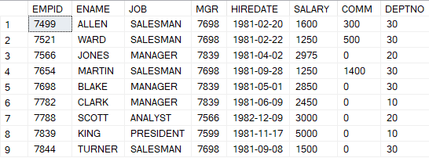

--2. Using explicit cursor fetch the employee name, employee_id and salary of all the records from EMPLOYEES table.

DECLARE @employee_id integer, @emp_name VARCHAR(50), @emp_salary integer;

DECLARE FETCH_CURSOR CURSOR FOR

SELECT EMPID, ENAME, SALARY FROM EMPLOYEE

OPEN FETCH_CURSOR

FETCH NEXT FROM FETCH_CURSOR INTO @employee_id, @emp_name, @emp_salary

WHILE @@FETCH_STATUS = 0

BEGIN

select @employee_id, @emp_name, @emp_salary

FETCH NEXT FROM FETCH_CURSOR INTO @employee_id, @emp_name, @emp_salary

END

CLOSE FETCH_CURSOR

DEALLOCATE FETCH_CURSOR

Output:

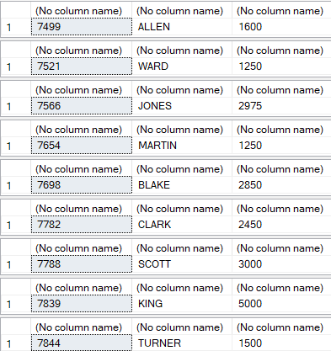

--3. Using explicit cursor Insert the records from EMPLOYEES table for the columns employee_id, Last_Name and salary for those records whose salary exceeds 2500 into a new table TEMP_EMP

CREATE TABLE EMPLOYEE_TEMP ( EMPID INTEGER, ENAME VARCHAR(30), SALARY INTEGER );

DECLARE @emp_id integer, @emp_name VARCHAR(50), @emp_salary integer;

DECLARE INSERT_CURSOR CURSOR FOR

SELECT EMPID, ENAME, SALARY FROM EMPLOYEE

OPEN INSERT_CURSOR

FETCH NEXT FROM INSERT_CURSOR INTO @emp_id, @emp_name, @emp_salary

WHILE @@FETCH_STATUS = 0

BEGIN

--select @emp_id, @emp_name, @emp_salary

IF @emp_salary>2500

insert into EMPLOYEE_TEMP(EMPID,ENAME,SALARY) VALUES (@emp_id, @emp_name,@emp_salary)

FETCH NEXT FROM INSERT_CURSOR INTO @emp_id, @emp_name, @emp_salary

END

CLOSE INSERT_CURSOR

DEALLOCATE INSERT_CURSOR

SELECT * FROM EMPLOYEE_TEMP

ORDER BY EMPID